Press Release

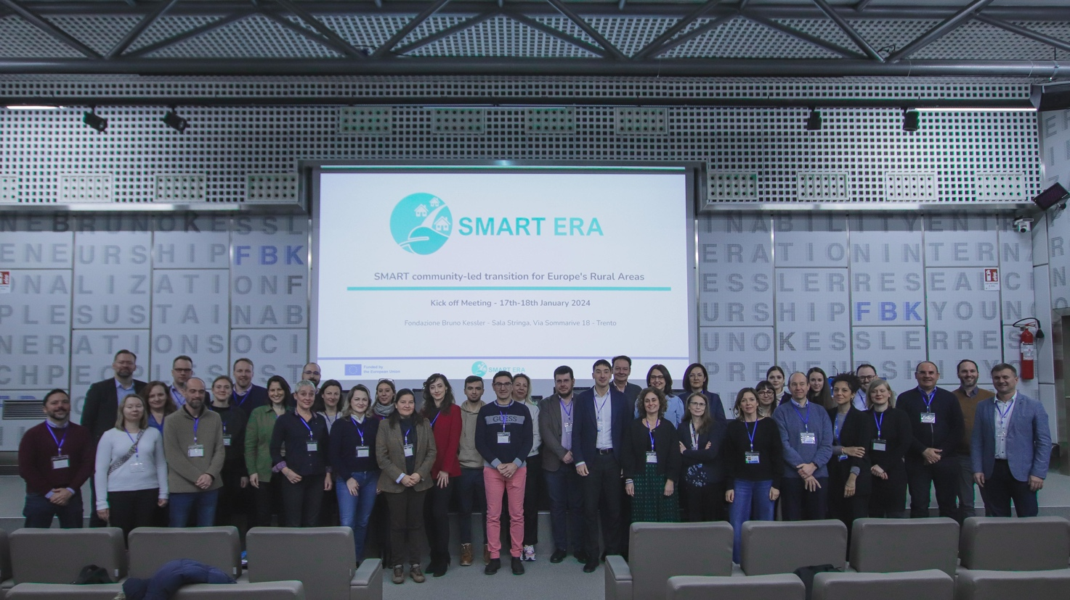
Photo credit: Andrea Franceschini

European project revitalises rural areas with smart innovation packages

Trento, Italy – January 17-18, 2024: The EU-funded project SMART ERA, worth €6.5 million, aims to revitalise rural areas using smart innovation packages to combat depopulation.
A new project – Smart Era – has been launched to empower rural communities which are facing socio-economic and environmental challenges. Using co-developed solutions bundled into "smart innovation packages, the 4-year project fosters a community-led pathway to change and covers technology, governance, business, societal aspects, and policy making.
Rural areas are often perceived as lagging behind, facing fewer services, structural issues, limited job opportunities, and an aging population. The ongoing digital revolution, coupled with the rise in remote and location-free work opportunities, offers a unique chance to redirect migration flows back to rural landscapes.

In this respect, the 25-strong Smart Era consortium from 10 countries recognises the need for strategic interventions and to capitalise on trends like multi-local living. The aim is not only to address the challenges of the communities but also to find innovative solutions together within the project.
Project coordinator Matteo Gerosa from FBK states: "I am confident that the SMART ERA project will represent a significant step towards constructing more environmentally friendly, compact, sustainable, and innovative growth models in rural Europe. It will integrate technological solutions and social innovation to provide a strategic response to the challenges posed by depopulation, with the goal of reversing migration flows and igniting sustainable growth. I appreciate the opportunity to lead a remarkable and skilled team of 25 partners from 10 European countries, all dedicated to shaping intelligent and sustainable development in rural areas."
The project will innovate at six pilot sites:
- Trentino (Italy),
- Tramuntana/Sóller (Spain),
- Northern Ostrobothnia (Finland),
- East Herzegovina (Bosnia and Herzgovina),
- Šmarje (Slovenia, Italy, Croatia)
- Devetaki Plateau (Bulgaria).

These sites will work to enhance their communities' ability to address challenges, promoting cooperation not only within their regions but also in line with the EU macro-regional strategies.
Lastly, SMART ERA will manage two distinct open calls – one for the replication of its solutions in follower rural regions and another for third-party projects. This will broaden the project's expertise and foster collaboration.

Contacts:
Project coordinator:
Matteo Gerosa, Fondazione Bruno Kessler (FBK), gerosa@fbk.eu
Communication Manager:
Angela Marzorati, C&D Officer, angela.marzorati@icons.it

